#### **Task #1**

**Key differences in SDLC & STLC and process**

#### **Key Difference between SDLC and STLC**

* SDLC defines all the standard phases which are involved during the software development process, whereas the STLC process defines various activities to improve the quality of the product.
* SDLC is a Development Life Cycle, whereas STLC is a Testing Life Cycle.
* In SDLC, the development team creates the high and low-level design plans, while In STLC, the test analyst creates the System, Integration Test Plan
* In SDLC, real code is developed, and actual work takes place as per the design documents, whereas in STLC testing team prepares the test environment and executes test cases.
* The SDLC life cycle helps a team complete the software’s successful development, while the STLC phases only cover software testing.

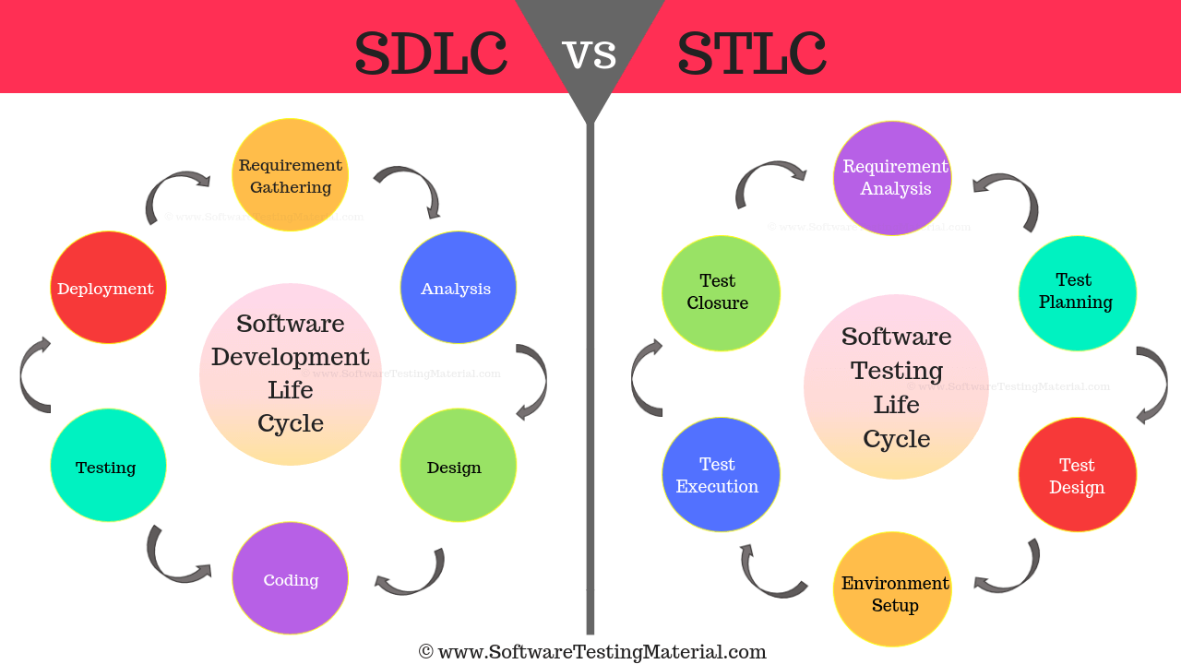  
  
SDLC vs STLC

## ****What is SDLC?****

****Software Development Life Cycle**** (SDLC) aims to produce a high-quality system that meets or exceeds customer expectations, works effectively and efficiently in the current and planned information technology infrastructure, and is inexpensive to maintain and cost-effective to enhance.

## ****What are the different phases of SDLC?****

The different phases of the Software Development Life Cycle are:

1. Requirement Phase   
   2. Analysis Phase  
   3. Design Phase  
   4. Development Phase  
   5. Testing Phase  
   6. Deployment & Maintenance Phase

### ****What is the Key Features of SDLC ?****

### Some of the key features of SDLC are –

1.It comes with detailed documentation of the functions, model structure, and test environment.

2.SDLC offers an efficient risk management concept that can be utilized by software developers to reduce their exposure to risk.

3. It provides step-by-step software development and testing which helps in completing the project before the deadline.

4. With SDLC, the developers, designers, project managers, and business analysts get a clear understanding of their roles and responsibilities in the project.

5.It is a cost-effective process.

## ****Why SDLC?****

Some of the reasons why SDLC is important in Software Development are as follows.

* It provides visibility of a project plan to all the involved stakeholders
* It helps us to avoid project risks
* It allows us to track and control the project
* It doesn’t conclude until all the requirements have been achieved

## ****What is Software Testing Life Cycle (STLC)?****

Software Testing Life Cycle (****STLC****) identifies what test activities to carry out and when to accomplish those test activities. Even though testing differs between organizations, there is a testing life cycle.

## ****What are the different phases of STLC?****

The different phases of the Software Testing Life Cycle are:

1. Requirement Analysis  
   2. Test Planning  
   3. Test Design  
   4. Test Environment Setup  
   5. Test Execution  
   6. Test Closure

**What are the Key Features of STLC ?**

Some of the key features of STLC are –

1. It determines the system testing type and method.
2. STLC analyzes the system requirements that the software development team gathered from clients and stakeholders.
3. STLC process helps in developing a traceability matrix.
4. Helps in prioritizing the software feature that needs to be tested the most.
5. Describes the test environment setup.
6. Assesses automation feasibility.

**Why STLC?**

Some of the reasons why STLC is important in Software Testing are as follows.

* STLC helps various testing teams to carry out quality improvement activities in different ways.
* It is easy to understand and implement regardless of its development phase and testing processes.
* In STLC, the execution phase develops a high-quality software release.
* Here tests are conducted on each module of the software before the closure of successful software development.
* It helps in improving the efficiency, and consistency of the software testing process.
* Software testing life cycle helps in improving the quality of the software development.
* It helps in removing the flaws of the software at the early stage.
* STLC assures that clients and end-users of the product receive the best results.
* It helps in optimizing the quality control in the entire SDLC process

## ****What is the difference between SDLC & STLC (SDLC vs STLC)?****

| **Criterion** | **SDLC** | **STLC** |
| --- | --- | --- |
| Origin | Development Life Cycle | Testing Life Cycle |
| Stands for | SDLC stands for Software Development Life Cycle | STLC stands for Software Testing Life Cycle |
| Definition | Software Development Life Cycle (SDLC) aims to produce a high-quality system that meets or exceeds customer expectations, works effectively and efficiently in the current and planned information technology infrastructure, and is inexpensive to maintain and cost-effective to enhance. | Software Testing Life Cycle (STLC) identifies what test activities to carry out and when to accomplish those test activities. Even though testing differs between Organizations, there is a testing life cycle. |
| Focus | On both development and testing process | On only testing process |
| Relationship | It is taken as the predecessor | It is taken as the successor |
| Phases | Requirement Gathering, Analysis, Design, Coding, Testing, Deployment & maintenance | Requirement Analysis, Test Planning, Test Design, Environment Setup, Test Execution, Test Closure |
| Requirement Gathering Phase | Business analyst gathers the requirements and create Development Plan | QA team analyses requirement documents and create System Test Plan |
| Design Phase | The development team develops the high and low-level design of the software based on the requirements | Test Architect or a Test Lead usually plan the test strategy |
| Coding Phase | The actual code is developed as per the designed document | The QA team prepares the test environment |
| Testing Phase | Actual testing is done in this phase. It includes Unit, Integration, System, Retesting & Regression testing etc., Also the development team involves in fixing the bugs reported | Actual testing is done in this phase. Defect reporting & retesting is done here |
| Deployment or Maintenance Phase | The development team involves in support and release updates | The QA team executes regression suites to check maintenance code deployed |
| When it is performed | The SDLC phases are performed before the STLC phases | The STLC phases are performed after the SDLC phases |
| Outcome | A good quality software product | A bug free software |

Software development is a very simple process that starts from system planning to its deployment. This simple process turns out to be a bit complicated when the developers have to create enterprise-level software solutions and not small products. And the reason behind it is that software development for complex systems requires a proper methodology and [QA services](https://www.tatvasoft.com/software-development-services/testing-qa" \t "https://www.tatvasoft.com/outsourcing/2022/08/_blank). This is why the concepts like Software Development Life Cycle and Software Testing Life Cycle have come into the picture. But if we compare SDLC vs STLC, these two approaches are interrelated to each other in some way.

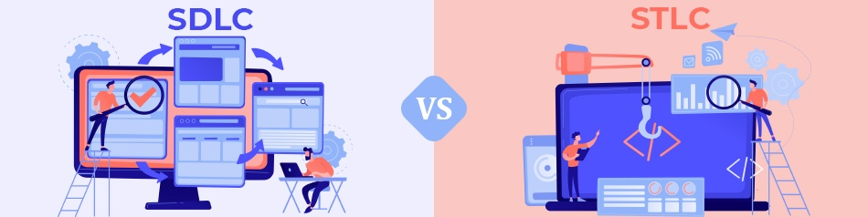

## ****Conclusion****

both SDLC and STLC are the two most important tools for software development while creating a perfectly secured system. SDLC is a system that offers a structured and phased approach while STLC validates the projects for their reliability, performance, and functionality. Besides, both of these tools are known as the top platforms that serve as a framework for software creation and testing.